UGANDA ADVANCED CERTIFICATE OF EDUCATION
MOCK EXAMINATIONS 2016
PHYSICS PAPER TWO
Time 2hours 30minutes

Instructions to candidates:
Answer five questions including at least one from each section, but not more than two from either sections C and D.
Where necessary assume the following constants:
Acceleration due to gravity, g = 9.81ms⁻²
Speed of light in vacuum, c = 3.0 x 10⁸ ms⁻¹
Electron charge, e = 1.6x10⁻¹⁹C
Electro mass = 9.11x10⁻³¹kg
Permeability of free space, μ₀ = 4.0πx10⁻⁷Hm⁻¹
Permittivity of free space, ε₀ = 8.85x10⁻¹²Fm⁻¹
The constant = 9x10⁹F⁻¹m
Speed of sound in air = 340ms⁻¹.

SECTION A
1 (a) Define (i) focal plane (1)
(ii) aperture of a lens (1)
(b)Describe how the focal length of a convex lens may be determined by a method involving graphical analysis (5)
(c)A concave lens of focal length 18cm is arranged coaxially with a convex lens of focal length 24cm, placed 4cm apart. An object is placed 30cm in front of the concave lens on the side remote from the convex lens.
(i) Find the position of the final image (5)
(ii) Using a point object draw a ray diagram to show the image formation (2)
(d) (i) Explain why a parabolic mirror is used in search lights instead of a concave mirror (3)
(ii) Explain two advantages of reflecting telescopes over refracting ones (3)
2 (a) Describe how the refractive index of a material of a prism may be determined using a spectrometer. (6)
(b) Define angular magnification of an optical instrument and eye ring (2)
(c) (i) Draw a ray diagram to show a Galilean telescope with the final image at the near point. (2)
(ii) Derive the angular magnification of the telescope in this setting (3)
(d) An astronomical telescope has an objective of focal length 120cm and an eye piece of focal length 8cm. If the telescope forms the final image 300cm from the eye piece, find the
(i) Separation of the lenses (4)
(ii) Angular magnification (3)
SECTON B
3 (a) State the principle of superposition of waves (1)

(b)
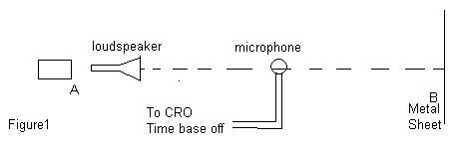
Figure1 shows a loudspeaker which produces a note of constant frequency. When a microphone connected to a C.R.O is moved from A to B, the length of the vertical trace on the C.R.O continually changes between maximum and minimum at equal distance
(i)Explain the above observation. (4)
(ii)Describe how you would use the above experiment to determine the velocity of sound in air (2)
(c)What is meant by: (c) (i) fundamental frequency and (1)
(ii) beats (1)
(d)Two open organ pipes of length 50cm and 51cm give beats of frequency 6.0Hz when sounding their fundamental notes together
(i)Neglecting end corrections, find the velocity of sound in air at that time. (3)
(ii)If the above experiment was carried out in a room at 0⁰C, find the velocity of sound at 27⁰C. (3)
(e) (i)Distinguish between mechanical and electromagnetic waves (2)
(ii)Explain the factors that determine the velocity of sound in air (3)
4(a) (i) What is meant by interference and diffraction of light waves (2)
(ii)State the condition necessary for formation of observable diffraction. (1)
(b)With a given diffraction grating used at normal incidence, a yellow line of wavelength λ=6.0×10⁻⁷m in one spectrum coincides with a blue line of 4.8×10⁻⁷m in the next order spectrum .If the angle of diffraction for these two lines is 30⁰, calculate the spacing between the grating lines. (4)
(c) (i) Describe how interference is formed in an air wedge. (5)
(ii) Explain the change in fringe pattern which occurs if the air in the wedge is replaced by transparent oil. (2)
(iii) Give two applications of interference of light. (2)
(d) The refractive index for light passing from air to medium X is 1.4. The speed of light in air is 3.0×10⁸ms⁻¹.Calculate the:
(i) Speed of light in medium X (2)
(ii) Wavelength of light of frequency 5.7×10¹⁴Hz in medium X. (2)

SECTION B
5(a)
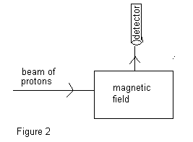
Figure2 shows an arrangement for deflecting charge into a detector. When protons enter the magnetic field of flux density 0.5T, with speed of 4.8×10⁶ms⁻¹they are deflected to enter the detector as above
(i) State the direction of the magnetic field (1)
(ii) Calculate the magnitude of force on each proton. (3)
(iii) If instead , a beam of electrons was directed along the same path into the field with the same velocity, state two changes that would need to be made on the magnetic field for the electrons to enter the detector along the same path (2)
(b)(i)With the aid of an appropriate diagram derive the expression for the magnetic torque experienced by a rectangular coil of N turns and dimensions a×b placed in a uniform magnetic field of flux density B, with its plane inclined to the field of an angle ,θ, and a current I is flowing through it. (5)
(ii)A square coil of side 3cm has 150 turns. The coil is mounted inside a solenoid of 600 turns per metre such that its plane makes an angle 30⁰ with the axis of the solenoid. If the coil is connected in series with the solenoid and a current of 1.2A is passed through the system, find the initial torque on it. (4)
(c)Explain why a moving coil galvanometer should have a radial magnetic field, fine hair springs and many turns (5)
6 (a)(i)With the aid of a diagram explain how a simple d.c motor works (5)
(ii)Explain the significance of a back emf in the operation of a d.c motor. (2)
(b)A motor of armature resistance 1.2Ω is operated from 240V d.c supply
(i)When the motor turns freely without a load, the current in the armature is 4.0A and the motor makes 400 revolutions per minute. Calculate the mechanical power converted. (2)
(ii)When a load is placed on the motor, the armature current increases to 60.0A. Find the new speed of rotation of the motor. (4)
(c)An air-cored inductor is connected in series with a switch and a d.c source. The switch is closed and left for some time. Explain why sparks is observed across the switch contacts when the switch is re-opened. (3)
(d)(i)What are eddy currents? (1)
(ii)Describe one application of eddy currents. (3)
7(a )Define (i)Inductive reactance (1)
(ii) Impedance (1) (b) An inductor of inductance L is connected across an a.c voltage source of V= V_{o}sin 2πft. Derive the expression for the reactance. (4)
(c)
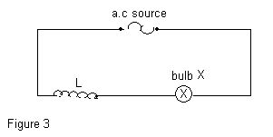
Figure 3 shows a circuit consisting of an air-cored coil L and bulb, and an alternating voltage source connected in series. An iron core is introduced into the coil. Explain why
(i) the bulb becomes dimmer. (3)
(ii) the iron core becomes warm. (2)

(d) A capacitor of capacitance 30μF is connected in series with a resistor of 80Ω, and an a.c voltage source of 150V mains and frequency 50Hz. Find the:
(i) current supplied by the source (4)
(ii) phase angle by which current leads the supply voltage. (2)
(e) Explain why a moving coil ammeter cannot be used to measure an alternating current from the mains. (3)
SECTION D
8(a)(i)Define one volt (1)
(ii)Two identical cells of emf 1.5V and internal resistance 1Ω each are connected in parallel, and then in series with two resistors of 2Ω and 3Ω. Find the power dissipated in the 3Ω resistor. (4)
(b)(i) Define electrical resistivity of a material (1)
(ii)Describe an experiment to determine the electrical resistivity of a material in form of a wire, using a meter bridge. (6)
(iii)The electrical resistivity of mild steel is 15×10¯⁸Ωm at 20⁰C and its temperature coefficient is 50×10⁻⁴k⁻¹.Calculate the resistivity at 80⁰C. (5)
(c)Explain why the resistance of metals increases with increase in temperature while that of semi-conductors reduce. (3)

9(a)(i) Define electric potential at a point (1)
(ii)
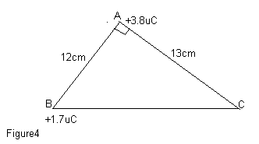
Figure 4 above shows charges of ⁺3.8μC and ⁺1.7μC placed at the vertices A and B of the triangle. Find the work done in transferring the 1.7μC charge from B to C. (4)

(b)(i)Describe how an electroscope can be used to distinguish between a conductor and an insulator.
(2)
(ii)Explain how a charged material attracts a neutral conductor. (2)
(iii)Explain using appropriate mathematical illustrations why the potential of a positively charged spherical conductor increases when a positively charged material is moved closer to it. (3)
(c)Describe an experiment to show that charge on a charged hollow conductor resides only outside the conductor. (5)
(d)
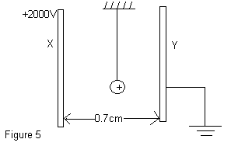
Figure 5 above shows two metal plates 0.7cm apart, with plate X at a potential of ⁺2000V relative to earth. A small particle carrying charge of ⁺47 μC is suspended in the space between the plates. Find the force experienced by the particle. (3)

10.(a) Define capacitance of a capacitor and relative permittivity of a material. (2)
(b)(i)Describe an experiment to determine to determine relative permittivity of a material using a ballistic
galvanometer. (4)
(ii)Explain why capacitance changes when a dielectric is placed between its plates. (4)
(c)Two identical capacitors of capacitance C in series, across a battery of voltage V. Show that when a
dielectric of relative permittivity ε_{r} is placed in one of the capacitors, the charge stored in the network
becomes
ε_{r}CV
1+ε_{r} (3)

(d)
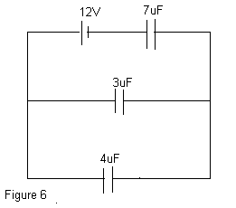
Three capacitors of capacitances 3μF, 4 μF, and 7μF are connected in a circuit as in figure 6. .Find the
(i)Charge stored on the 7μF capacitor. (4)
(ii)p.d across the 4μF capacitor. (3)

